MARK SCHEME
EDWEST CHEMISTRY STAGE 3 PAPER 2011
Section One
- C 16. A
- D 17. B
- A 18. B
- B 19. C
- D 20. C
- A 21. D
- B 22. C
- C 23. B
- D 24. D
- D 25. A
- D
- A
- B
- C
- B

Section Two

26. (a) (3)

Change | Effect
Adding dilute nitric acid | DECREASE
Adding sodium hydroxide solution | INCREASE
Adding silver nitrate solution | INCREASE

(b) (1)
Equilibrium constant expression | [H₃AsO₄][H⁺][I⁻]²  [H₃AsO₃][I₂]

27 (a) Endothermic (1)
(b) (3)
Change | Effect
Increasing the temperature | INCREASE
Increasing the volume of the system | DECREASE
Adding a catalyst | INCREASE

28. (a) Basic (1)
(b) Phosphate ions hydrolyse in water (1)
PO₄³⁻ + H₂O ⇌ HPO₄²⁻ + OH⁻ (1)
OH⁻ ions produced hence basic (1)

29. (a)
H₂CO₃ + H₂O ⇌ H₃O⁺ + HCO₃⁻ (2)
(b) OH (1)
C O
OH

(c) As [H⁺] increases reverse reaction is favoured (1) which would decrease concentration of H₃O⁺(1)
(d) 3.98 x 10⁻⁸ mol L⁻¹ (1)
30. Ethanol and water have H-bonding between molecules (1) and so can disrupt the inter molecular bonds (1). Paraffin has only dispersion forces between molecules (1). Therefore ethanol cannot disrupt bonding and form bonds itself with the paraffin.(1)

31. (a) An excess of 2-propanol is oxidised by acidified KMnO₄ (3 marks)

Observations | Colour change from purple to colourless (or pale pink)
Structural formula of organic product  Show all atoms | CH₃COCH₃
Name of organic product | propanone

(b) Methanoic acid reacts with 1-butanol in the presence of H₂SO₄ (3 marks)

Observations | Fruity smell produced (accept no visible reaction)
Structural formula of organic product  Show all atoms | C₄H₉OOCH
Name of organic product | Butyl methanoate

32.
Species | Structure (showing all valence shell electrons) | Shape (sketch or name) | Polarity of molecule (polar or non-polar)
Silicon hydride  SiH₄ | H  H Si H  H | Tetrahedral | Non-polar
Hydrogen cyanide  HCN | 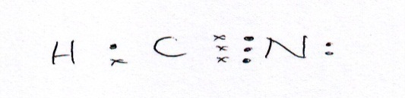 | Linear | Non-polar
Sulfite ion  SO₃²⁻ | 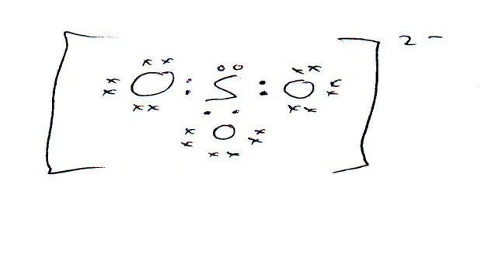  No brackets or charge no mark | Pyramidal | Polar
Boron trifuoride  BF₃ | 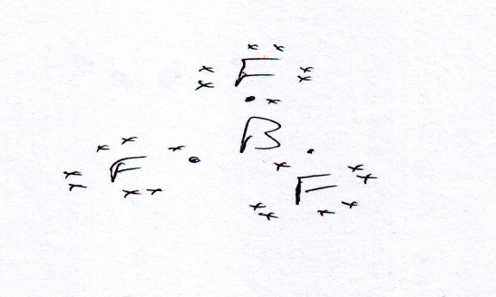 | Trigonal Planar | Non-polar

33. (a) Repeating unit is (1)
CH₃
C CH₂
COOCH₃

(b) (1)
CH₃
C CH₂
COOCH₃

(c) Addition (1)
(d) Ester (1)

34. (a) 3-methylbutanoic acid (1)
(b) (2)
(CH₃)₂CHCH₂CH₂OH + H₂O (CH₃)₂CHCH₂COOH + 4H⁺ + 4e⁻

(c) (3)
((CH₃)₂CHCH₂CH₂OH + H₂O (CH₃)₂CHCH₂COOH + 4H⁺ + 4e⁻) x 5
(8H⁺ + MnO₄⁻ + 5e⁻ Mn²⁺ + 4H₂O) x 4
--------------------------------------------------------------------------------------------------------------------------------------
5(CH₃)₂CHCH₂CH₂OH + 12H⁺ + 4MnO₄⁻ 5(CH₃)₂CHCH₂COOH + 4 Mn²⁺ + 11H₂O
1 mark for each equation (pay follow through for 3rd equation)
35. (a)
(i) Salt bridge drawn and labelled with suitable salt (1)
(ii) Cathode labelled – Ag/Ag⁺ (1)
(iii) Direction of electron flow labelled – from Ag to Cu (1)
(iv) Anode labelled – Cu/Cu²⁺ (1)
(b)
(i) Anode Cu Cu²⁺ + 2e⁻ (1)
(ii) Cathode Ag⁺ + e⁻ Ag (1)
(c) 0.46 V (1)
36. (a) Excludes water and oxygen from the surface of the iron (2) which are two of the reactants needed for rust to form (1)
(b) Fe Fe²⁺ + 2e⁻ -0.44 V
Sn Sn²⁺ + 2e⁻ -0.14V (1)
Fe stronger reductant than Sn (1)
Therefore Fe corrodes as electrochemical cell is formed (1)
(c) Zn Zn²⁺ + 2e⁻ -0.76 V
Fe Fe²⁺ + 2e⁻ -0.44 V (1)
Zn stronger reductant than Fe (1)
Therefore Zn corrodes as electrochemical cell is formed (1)
(d) Electrochemical cell formed (1) where Al and Fe are joined (1)
Al stronger reductant than Fe (1)
Therefore Al corrodes (1)

Section Three

37. (a)
n(KHC₄H₄O₆) = 350/(39.1+1.008+4x12.01+1.008x4+16x6)
= 350/188.18
= 1.8599 mol (1)
n(NaHCO₃) = 150/(22.99+1.008+12.01+3x16)
= 150/84.008
= 1.7855 mol (1)
1 mol KHC₄H₄O₆ 1 mol NaHCO₃
1.8599 ˃ 1.7855
Therefore NaHCO₃ is limiting reagent (2)
If students have correct answer but no working – no marks
(b) n(KHC₄H₄O₆)excess = 1.8599 – 1.7855
= 0.0744 (2)
m(KHC₄H₄O₆) = 0.0744 x 188.18
= 14.0 g (1)
(c) 1.7855 mol NaHCO₃ 1.7855 mol CO₂ (1)
V(CO₂) = (1.7855 x 8.315 x 453)/105
= 64.1 L (2)

(d) Let amount of NaHCO₃ = x g
Amount of (KHC₄H₄O₆) = (500-x)g (1)
n(KHC₄H₄O₆) = n(NaHCO₃)
(500-x)/188.18 = x/84.008
(500-x)84.008 = 188.18x
42004 - 84.008x = 188.18x
42004 = 188.18x + 84.008x
272.19x = 42004
x = 42004/272.19
= 154 g (2)
m (KHC₄H₄O₆) = 500 – 154
= 346 g (1)
Both answers quoted to 3 significant figures (1)

38.
Final reading (mL) | 20.60 | 19.65 | 20.75 | 20.80 | 19.05
Initial reading (mL) | 4.50 | 3.80 | 5.25 | 5.00 | 3.20
Titration volume (mL) | 16.10 | 15.85 | 15.50 | 15.80 | 15.85

- (15.85 + 15.85 + 15.80)/3 = 15.83 mL (1)
(b) 2NaOH + H₂SO₄ Na₂SO₄ + 2H₂O (1)
(c) Suitable indicator named (almost any would do) (1)
Titration of strong acid with strong base ` (1)
Equivalence point around pH 7 (1)
End point of indicator somewhere between pH 3-10 due to titration curve (1)
(d) [OH⁻] = [NaOH] = 10⁻¹⁴/5.0119 x 10⁻¹⁴
= 0.19953 molL⁻¹ (1)
n(NaOH) = 0.02 x 0.19953
= 3.9906 x 10⁻³ mol (1)
n(H₂SO₄) = 3.9906 x 10⁻³/2
= 1.9953 x 10⁻³ mol (1)
n(H₂SO₄) = (1.9953 x 10⁻³ x 500)/15.83
= 0.063023 mol (1)
= n(H₂SO₄) in 10 mL (1)
C (H₂SO₄) in battery = 0.063023/0.01
= 6.30 molL⁻¹ (1)

39. (a)
m(C) = (5.51 x 12.01)/44.01 = 1.5036 g
%C = (1.5036 x 100)/2.31 = 65.1% (1)
m(H) = (2.81 x 1.008 x 2)/18.016 = 0.31444 g
%H = (0.31444 x 100)/2.31 = 13.6% (1)
%O = 100 – 65.1 – 13.6 = 21.3% (1)
C H O
Ratio by mass 65.1 13.6 21.3
Ratio by mol 65.1/12.01 13.6/1.008 21.3/16
5.42 13.49 1.33
Divide by smallest 5.42/1.33 13.49/1.33 1.33/1.33
4.075 10.143 1
4 10 1
Empirical formula C₄H₁₀O (4)

- 4 x 12.01 + 1.008 x 10 + 16 = 74.12 (1)
Therefore molecular formula = empirical formula
Molecular formula = C₄H₁₀O (1)

Draw and name two possible structures of compound X (4 marks)

Structure  CH₃CH₂CH₂CHO | Structure  CH₃CHCH₃CHO
Name  Butanal | Name  methylpropanal

Draw and name two possible structures of compound Y. (4 marks)

Structure  CH₃CH₂CH₂COOH | Structure  CH₃CHCH₃COOH
Name  Butanoic acid | Name  Methylpropanoic acid

40. (a)
n(Mg₂P₂O₇) = 0.0364/(24.31x2 + 2x30.97 + 16x7)
= 0.0364/222.56
= 1.63551 x 10⁻⁴ mol (1)
2 mol MgNH₄PO₄ 1 mol Mg₂P₂O₇ (1)
n(MgNH₄PO₄) = 2 x 1.63551 x 10⁻⁴ mol
= 3.27102 x 10⁻⁴ mol (1)

n(MgNH₄PO₄) = n(PO₄³⁻) in 20 mL = 3.27102 x 10⁻⁴ mol (1)
n(PO₄³⁻) in 250 mL = (3.27102 x 10⁻⁴ x 250)/20
= 4.0888 x 10⁻³ mol (1)
m(PO₄³⁻) = 4.0888 x 10⁻³ x (30.97 + 16 x 4)
= 0.38831 g
% = (0.38831 x 100)/6.15
= 6.31% (1)

(b) (4)
Action | Calculated result would be too low | No effect on calculated result | Calculated result would be too high
A. All of the MgNH₄PO₄ was not precipitated. | √
B. All of the fertiliser did not dissolve. | √
C. The conical flask had been previously washed with water but not dried. |  | √
D. The MgNH₄PO₄ precipitate was not washed with water. |  |  | √

Makes no difference to the number of mol of phosphate ions transferred to the conical flask. (1)
(c) 50.0 kg of fertiliser contains 5.00 kg of K (1)
n(K) = 5000/39.1 = 127.88 mol
n(K) = n(KNO₃) = 127.88 mol (1)
m(KNO₃) = 127.88(39.1 + 14.01 + 16x3)
= 12930 g
= 12.9 kg (1)
- Soluble (1) and also contains N which is a nutrient. (1)
41.
(a) m(Cu) = 98% x 10⁶ g
= 980 000 g (1)
n(Cu) = 980 000/63.55
= 15421 mol (1)
1 mol Cu 1 mol CuFeS₂ (1)
15421 mol Cu 15421 mol CuFeS₂ (1)
m(CuFeS₂) = 15421 x (63.55 + 55.85 + 32.06 x 2)
= 15421 x 183.52
= 2.83 tonnes (1)

(b) n(Cu) = 15421 mol
1 mol Cu = 3 mol SO₂ (1)
15421 mol Cu = 3 x 15421 mol SO₂
= 46263 mol SO₂ (1)
150 x V(SO₂) = 46263 x 8.315 x 1773
V(SO₂) = (46263 x 8.315 x 1773)/150
= 4.55 x 10⁶ L (2)

(c) Acid rain (1)

42.
Some points to consider
- Solubility and boiling points will depend upon extent of H-bonding
- All are alcohols so have –OH group and will H-bond
- Strength of H-bond will depend on the extent to which the –OH group is exposed and available for bonding
- Compounds differ as they are all isomers of C₄H₉OH
- 1-butanol and 2 - methyl -1-propanol are primary alcohols
- 2 – butanol is a secondary alcohol
- 2 – methyl -2 – propanol is a tertiary alcohol
- Structural formulas would be good if drawn
- Expect primary alcohols to be more soluble and have a highest BPts as –OH is more exposed and available for H-bonding
- Tertiary alcohol will be least soluble and lowest Bpt as H-bonding is weakest of the compounds as –OH group is least exposed
- Need to discuss solubility as between molecules that can form intermolecular bonds with each other
- All exhibit dispersion forces

